Guidance on running the automated datavyu scripts

For EXALONE assessment

1.Open an EXALONE spreadsheet that you want to run the script on.

2.Click the the option of ‘Script’ on the top menu bar. Then Click ‘Run Script’



3.Select the file Script_Check-codes_EXALONE.rb to run



4. The Scripting Console should say the selected script has successfully finished running.



5.Go to Desktop. Find the output file 104_MF_EXALONE_errors.txt to check errors existing in the specified EXALONE file (Note: the name is specified by the datavyu file’s ID column) From top to the bottom in the file describes four possible errors in EXALONE file.

* + Missing Input

Indicate #Column #Cell that missed a Behavior Input

* + Spelling Error

Indicate #Column #Cell that a Behavior had been wrongly spelt

* + Wrong Duration

Indicate #Column #Cell that the duration of a Behavior was zero or negative

* + Non-continuous Duration

Indicate #Column (rhormv, lhormv, rvertmv, lvertmv) #Cell that the Behavior’s duration onset was not continuous to its previous Behavior’s offset



6. User needs to manually correct these errors to make sure no errors happen (This file will be empty if there are no errors)

7. Run Script of Script_Raw_Export_EXALONE.rb and Script_Summary_Export_EXALONE.rb



8. The Scripting Console should say the selected script has successfully finished running

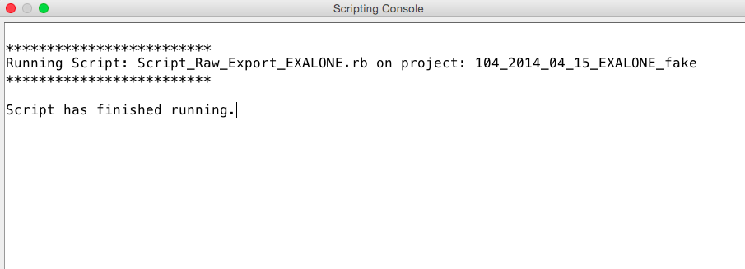

9. Go to Desktop. Find 104_MF_EXALONE_raw.txt and 104_MF_EXALONE_summary.txt.

Select all the text. Copy and paste to an Excel file.

User should be able to check the output of a EXALONE file and analyze the results on the Excel file after this step





For RCHLOC assessment

1. Open an RCHLOC spreadsheet that you want to run the script on.
2. Click the the option of ‘Script’ on the top menu bar. Then Click ‘Run Script’



1. Select the file Script_Check-codes_RCHLOC.rb to run



1. The Scripting Console should say the selected script has successfully finished running.



1. Go to Desktop. Find the output file 104_MF_RCHLOC_errors.txt to check errors existing in the specified RCHLOC file (Note: the name is specified by the datavyu file’s ID column) From top to the bottom in the file describes three possible errors in RCHLOC file.



* + Missing Input

Indicate #Column #Cell that missed a Behavior Input

* + Spelling Error

Indicate #Column #Cell that a Behavior had been wrongly spelt

* + Wrong Duration

Indicate #Column #Cell that the duration of a Behavior was zero or negative

6-9. Execute the same operations as the EXALONE assessment with corresponding RCHLOC scripts